

A
DATA STRUCTURE
PROJECT



SUMMITED TO : MR. GAURAV SAXENA

SUBMITTED BY :

KETAN RAJORIYA (9912103533 )

NITESH GOYAL ( 9912103525)

SAURAV ARORA (9912103543 )

SHREYANS PATHAK ( 9912103526)

PROJECT PROBLEM STATEMENT

Security problem.

Updating problem.

Maintenance of accounting holder’s records those are available in the book.

Maintenance of daily transaction that are going on in the bank.

Maintenance of different account for the annual closing of account bank.

Searching creation.

Overview/introduction to project
The basic banking suite provides a global accounting foundation that
provides the all private banks with electronic banking facilities. It allows the
client of private banks to carry out their day to day banking transactions.
banking is all about knowing our customer need and provide them with
the right service at the right time through right channel 24*7 day a week.
Being “electronic”, it not only provides its customers with faster and better
facilities, it even reduces the manual overhead of accounts maintenance.
In this project we are going to do following tasks:-
- New costumer Entry.
- Withdrawl Transaction.
- Deposit Transaction.
- Account Detail.
- Other Feature like pay slip transaction, cheque transaction, d.d transaction.
- Setting.

DATA STRUCTURE USED

Double link list,recursion.

PROGRESS PROJECT

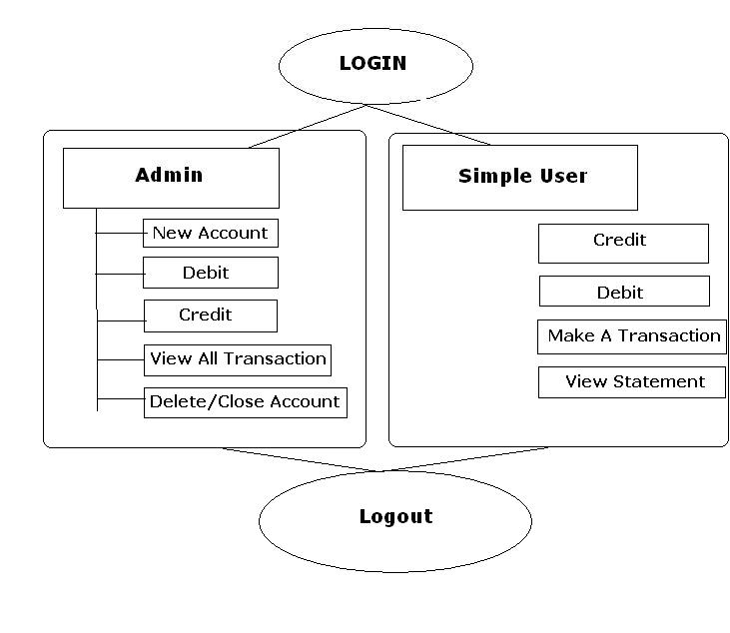

1.login can be by a simple user or by a Admin, these User ID and password.

2. Here we can see that an Admin has the options...
1. New Account - To Create New Account
2. Credit - To credit any account
3. Debit - To Debit any account
4. All Transaction - TO check transaction in bank
5. Balance Enquiry - Can check balance in any account
6. Delete Account - TO delete or close any account

Here we can see a user has the options...
1. Account Summary - Statement
2. Cash Deposit - To credit account
3. Cash Withdraw - To Debit account
4. Transaction - To transfer money from his/her account to any other account
5. Balance Enquiry - To check balance in account

3. I gave an option to user to debit and credit any account.

4. user can check balance by selecting account from drop down list by using this form..

